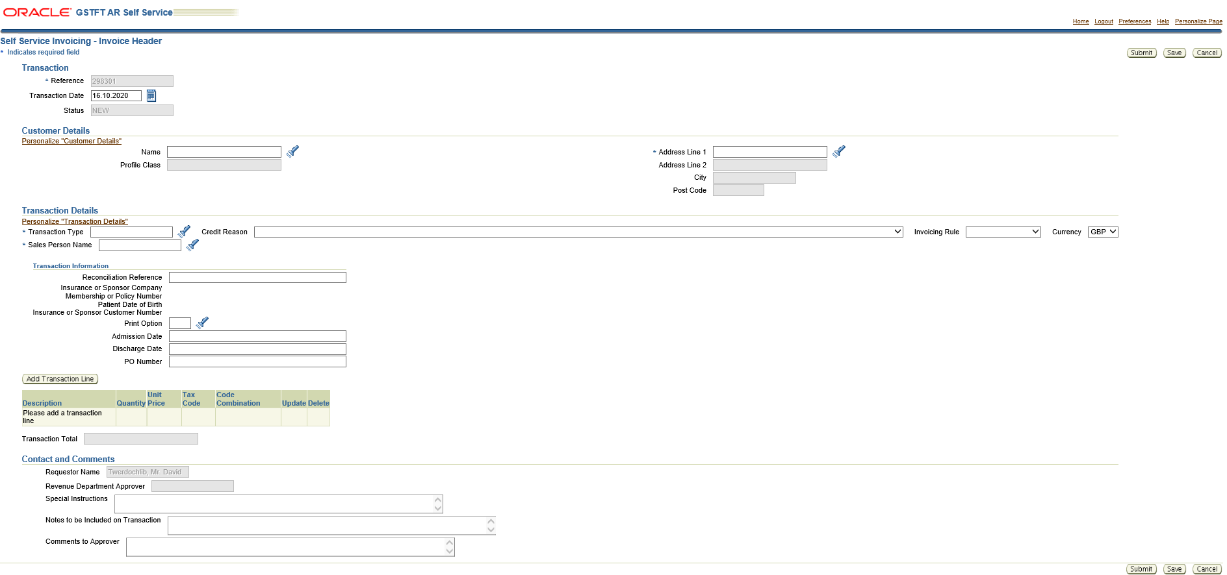
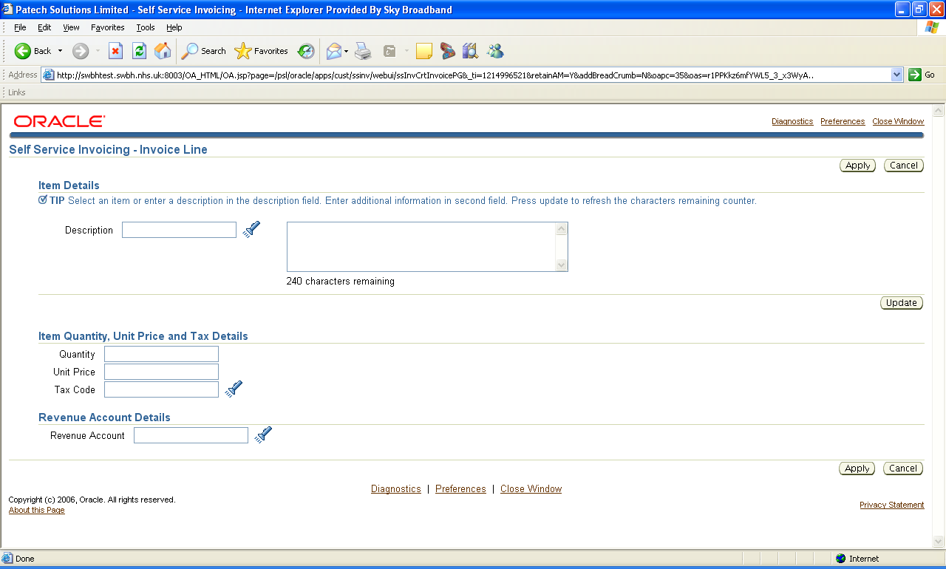

AR Self Service Workshop Design Discussion

Authentication:
IDCS will be used to manage the users(around 350), groups and roles
What will be the core user groups
2 groups
Submitters
Approvers
AR self service Application Features:
Create Invoice Request
Search for Invoice Requests
Update Invoice Requests that are not approved
Copy Invoice Requests from completed invoices from AR Self Service Application
Copy all fields but, those in red
Only copy invoice requests from the same requestor
Delete Invoices
Never Submitted
Rejected
Interface Invoice into AR for approval
Review and Approve Invoices
(Employee DFF will have the approver information
workflow with 3+3+3 notification period timeout period, between the requester and approver)
workflow with 3+3+3 notification period timeout period, between the Approver and GSTTIDM/ETLIDM
workflow with 3+3+3 notification period timeout period, between the GSTTIDM and CFO for Credit Notes

GSTTIDM, will use the existing group email

Notification Templates
Make Approve ad Reject Buttons far away from each other
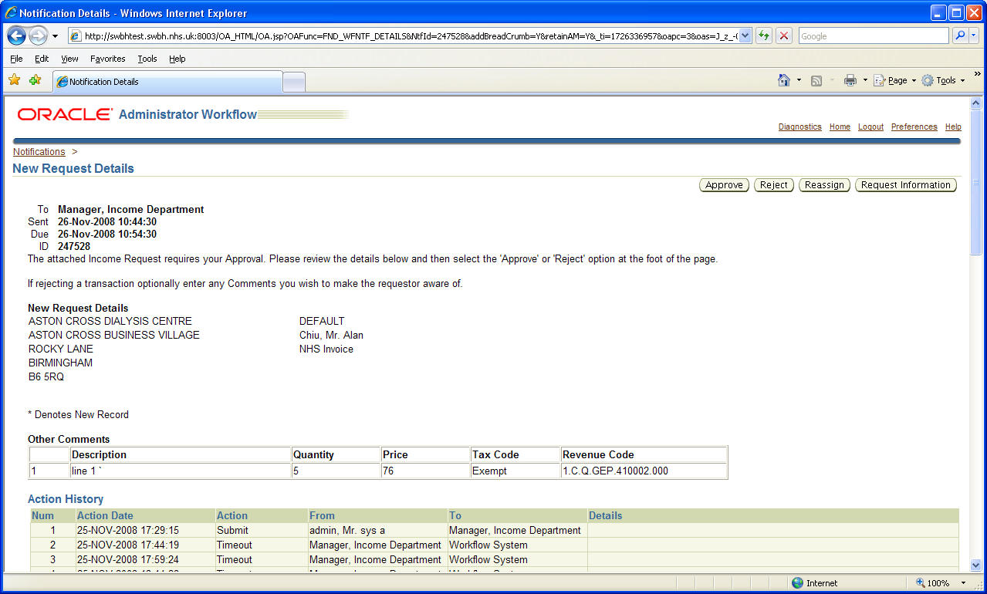
Landing Page
Should show all the pending notifications, total number of notifications
Document Reference
Approver
Requestor
Sent date
Transaction Type
Amount

Create Invoice Page:
Page Validations when opening:
Does the requestor has a valid approver or not.
Organization Code, if Organization code is based on the selection
Page Validations when Saving:
None So far

Page Validations when Submitting:

Data Synchronization from ERP Cloud :
Realtime
Every 1 hr
Nightly
On Demand

Data Cleansing needed for Credit Reason list of values
Invoice rule, version1 to check if Invoice in Advance is possible in Oracle ERP Cloud

Other Recharge and Salary Recharge Invoice will have extra fields
Analysis and Spare segments should be updateable
Organization is parking lot
Cost centre from sales person
Income from memo lines
WGA code is from customer/charity/acl
Analysis is updatable
Intercompany from customer
Spare is default 0000 and updatable

Vesion1 to come back on the scenario where lines should be able to split the distribution to multiple cost centres

Section | Column Name | Data Source | Display Element Type | Comments
Transaction
 | Reference | OIC | System generated reference number
 |  | OIC | Updatable date field
  Transaction Date
 | Status | OIC | Not Editable | Reflects the status of the transaction
Customer Details
 | Name | ERP Cloud | Lov Based | Synced every 12hr  On Demand
 | Address | ERP Cloud | Lov Based | Synced every 12hr  On Demand
 | Profile Class | ERP Cloud | Not Editable | Synced every 12hr  On Demand
Transaction Details
 | Transaction Type | ERP Cloud | Lov Based | Synced overnight
 | Sales Person Name | ERP Cloud | Lov Based | Synced every 12hr  On Demand
 | Credit Reason(Does GSTT uses this for Credit Notes) | ERP Cloud | Lov Based | Synced overnight
 | Invoicing Rule | ERP Cloud | Lov Based | Synced overnight
 | Currency | ERP Cloud | Lov Based | Synced overnight
Transaction Information
 | Reconciliation Reference |  | Text Field
 | Insurance or Sponsor Company |  |  | Defaulted from Customer Information
 | Membership or Policy Number |  |  | Defaulted from Customer Information
 | Patient Date of Birth |  |  | Defaulted from Customer Information
 | Insurance or Sponsor Custom Number |  |  | Defaulted from Customer Information
 | Print Option | ERP Cloud | Lov Based | Synced overnight
 | Admission Date |  | Text Field
 | Discharge Date |  | Text Field
 | PO Number |  | Text Field
 | Other Recharge Reason
Self Service Invoicing - Invoice Line
 | Description | ERP Cloud | Memo Line Item Name  Memo Line Item Description  Income Code  List of values, but can be overwritten | Lov as well as updatable field  Synced every 12hr  On Demand
 | Additional Description |  | Text Field
 | Quantity |  |  | Default Value 1
 | Unit Price
Revenue Account Details
 | Organization | ERP Cloud |  | Synced Overnight  On Demand
 | Cost Centre |  |  | Synced Overnight  On Demand
Synced Overnight
On Demand
Synced Overnight
On Demand
Synced Overnight
On Demand
Synced Overnight
On Demand
Synced Overnight
On Demand
Synced Overnight
On Demand
 | Line Reconciliation Reference |  | Text Field
 | Transaction Total
Contact and Comments
 | Requestor Name |  | From user Record
 | Revenue Department Approver |  | ERP Cloud | Employee DFF
 | Special Instructions
 | Notes to be included on Transaction
 | Comments to Approver

Questions:
Transaction line, should we create in the same screen or need to open a new screen

Create Invoice Line Page:
Page Validations when opening:

Page Validations when Applying:
Account code combination validation
VAT Code

Search Invoice Requests Page:

Status – New, Created, Submitted, Approved, Rejected
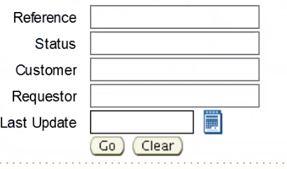

Add amount for search criteria,
Make Status as Drop Down
In the search results, if the invoice request is complete, then it will have a copy option
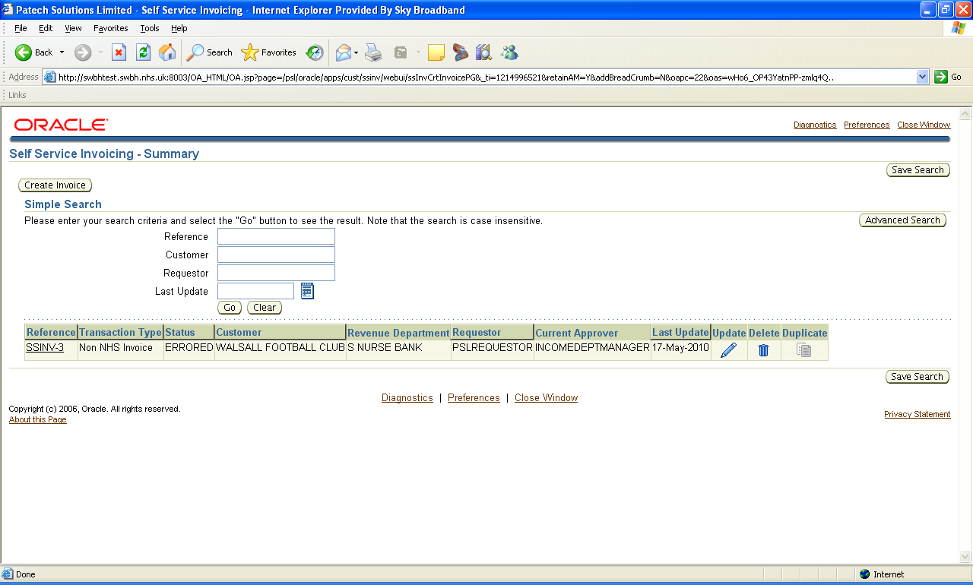
Approval Process:

For Invoices, after submitting by requestor
The invoice request goes for approval by the requestor manager
Once approved it goes to GSTTIDM/Alex Team for approval, when approving they can select if the AR transaction can be created as Complete(Default) or Incomplete
Once approved it is interfaced to Oracle ERP Cloud to be created as an AR Transaction.
For Credit notes, we need another level of approver in the process
The Credit Notes request goes for approval by the requestor manager
Once approved it goes to GSTTIDM/Alex Team for approval
Alex team will forward the approval to CFO if the credit note amount is more than 100K
Once approved it is interfaced to Oracle ERP Cloud to be created as an AR Transaction.

